
HPSEBL FOG/DG Set NOC Portal
User Manual 1.0
Application Link: https://eportal.hpsebl.in/noc/admin

Login Screen: Select your office type and then just login using location code and default password 12345. You have to change default password after login. Login screen will be same for Sub Division, Division and Circle.
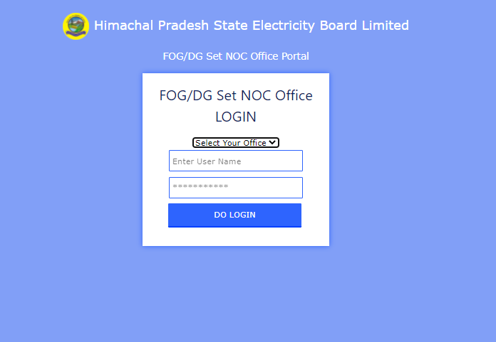

Process for Sub Division Office:

Home Page:
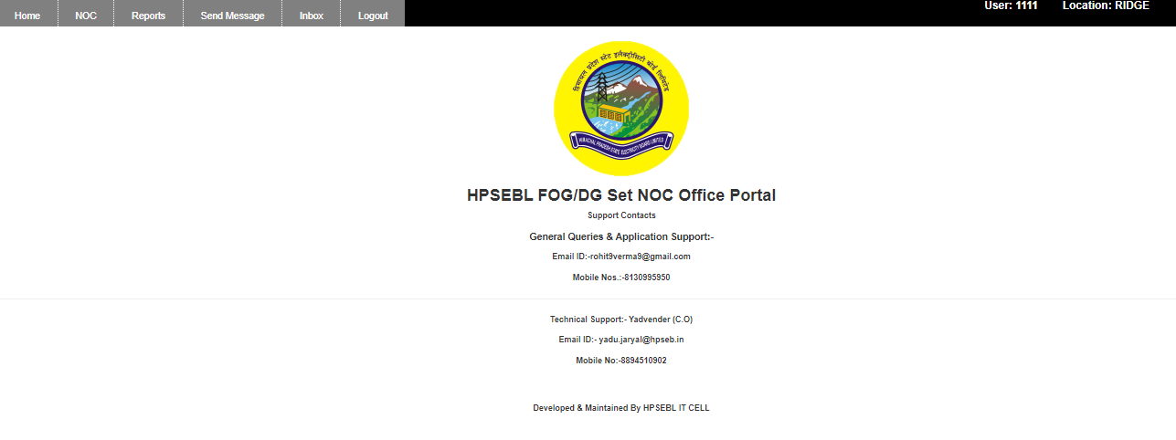

Forward or reject NOC application: In this screen you can forward or reject NOC application. Just select application no. from drop down and you will get all details of applicant. After verifying all particulars you can forward or reject application. You can download all applicant documents from here.

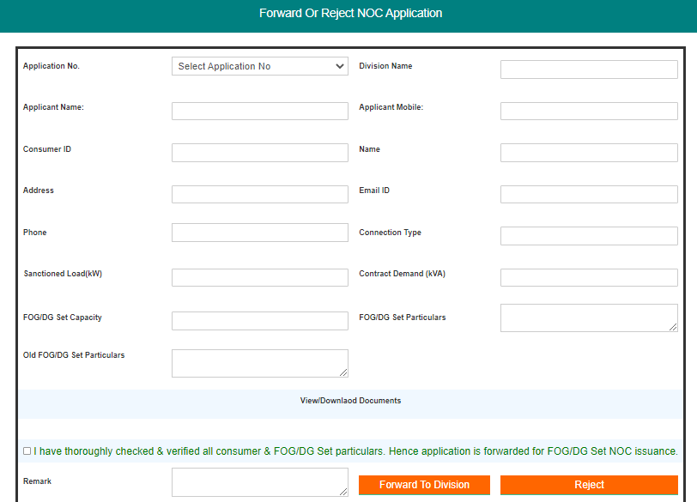

Final Certificate by AE/AEE: On this screen you can submit final certificate after NOC approval.
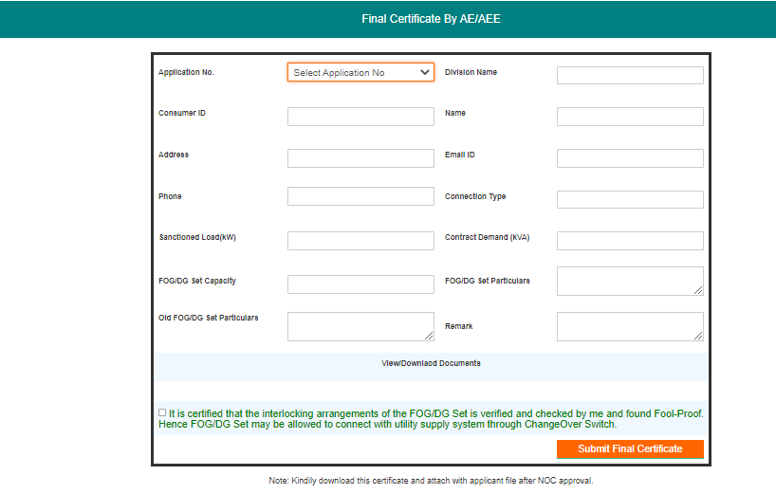

View or Download NOC & Application: On this screen you can view applicant details and can download applicant application and approved NOC.

View applications pending for final certificate: On this screen you can check applications which are approved and pending for SDO final certificate.

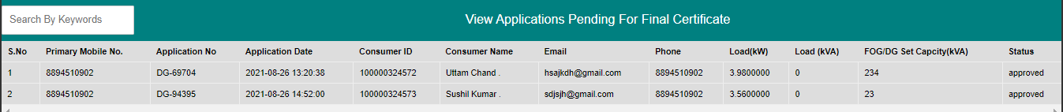

Print and Download Final Certificate: On this screen you can download SDO final certificate. Please download final certificate and attach it with applicant file.

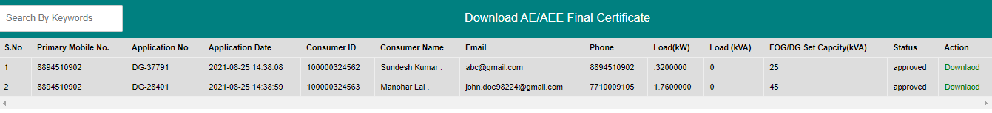

Send Message:- On this screen you can reply to applicant queries.

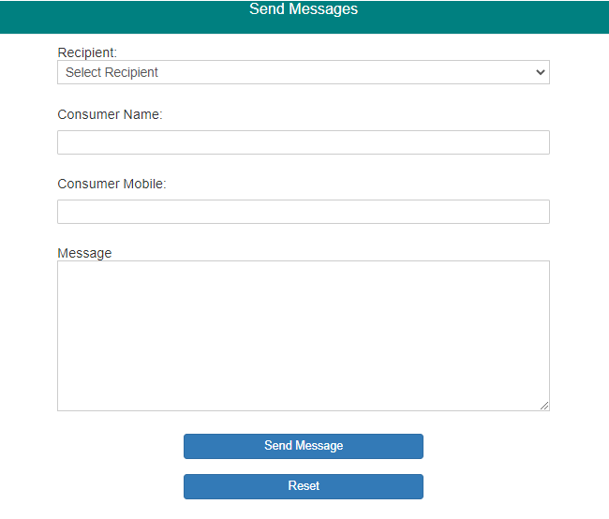

Inbox : On this screen you can see applicant issues and messages.
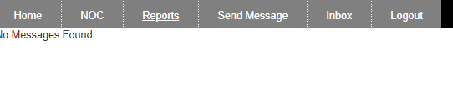

Process for Division Office:

Home Page:
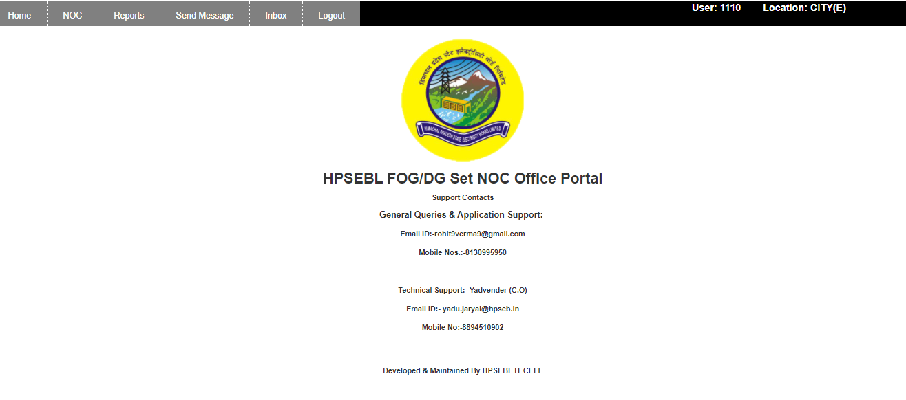

Approve Forward or Reject Application: In this screen you can approve, forward or reject NOC application. Just select application no. from drop down and you will get all details of applicant. After verifying all particulars you can issue NOC, forward to Circle or reject application. You can download all applicant documents from here. While issuing NOC please ensure that your office is capable to approve DG Set Capacity or not. To issue NOC just download the format from application and prepare NOC then upload NOC on this screen and click Issue NOC button.
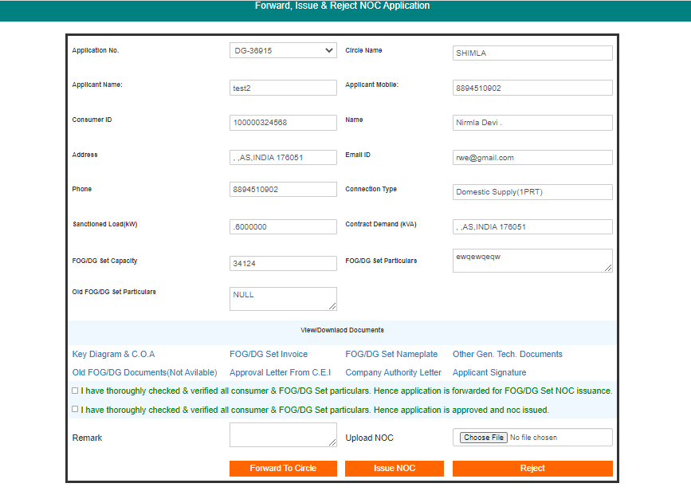

View or Download NOC & Application: On this screen you can view applicant details and can download applicant application and approved NOC.

Send Message:- On this screen you can reply to applicant queries.

Inbox : On this screen you can see applicant issues and messages.

Process for Circle Office:-
Home Page:
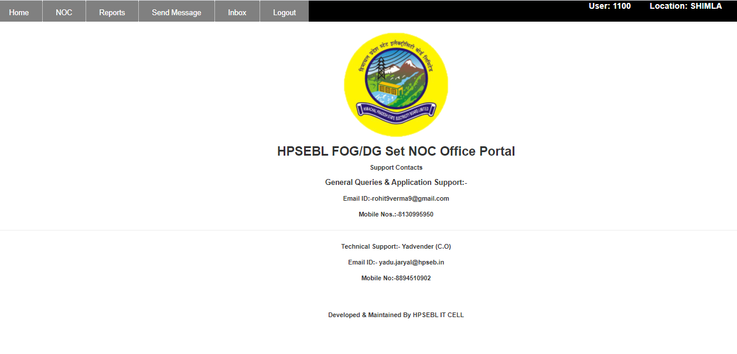

Approve or Reject Application: In this screen you can approve or reject NOC application. Just select application no. from drop down and you will get all details of applicant. After verifying all particulars you can issue NOC or reject application. You can download all applicant documents from here. To issue NOC just download the format from application and prepare NOC then upload NOC on this screen and click Issue NOC button.

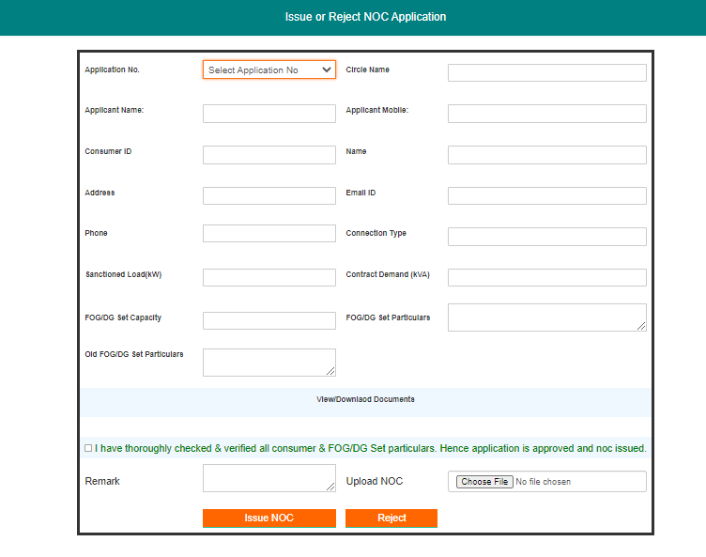

View or Download NOC & Application: On this screen you can view applicant details and can download applicant application and approved NOC.

Send Message: - On this screen you can reply to applicant queries.

Inbox : On this screen you can see applicant issues and messages.

