HPSEBL FOG/DG Set (Standby) NOC Portal
User Manual 1.0
Application Link https://eportal.hpsebl.in/noc

Login Screen: No need to register just login with your mobile number. Remember the mobile number used for login will be primary mobile number for NOC application.
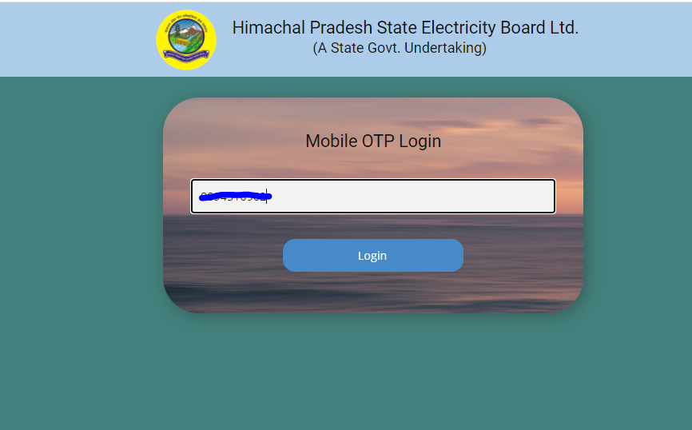

Verify OTP: Verify OTP sent to your mobile number and click verify.
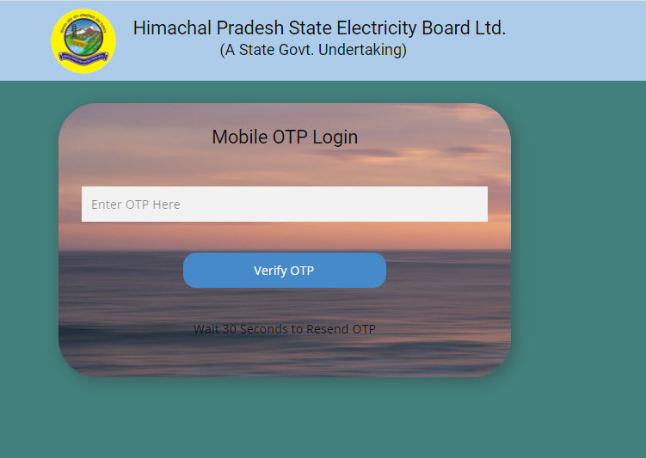

Home Page:
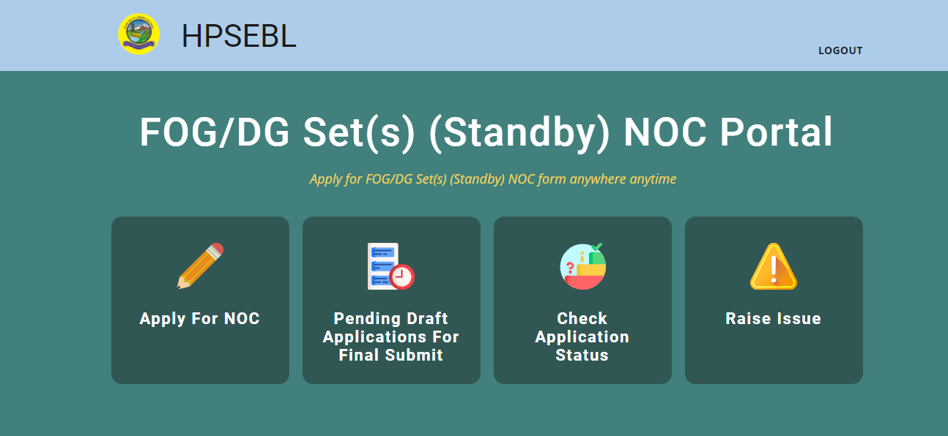

Apply For NOC
1st Step: Enter your consumer id by which you want to apply for NOC
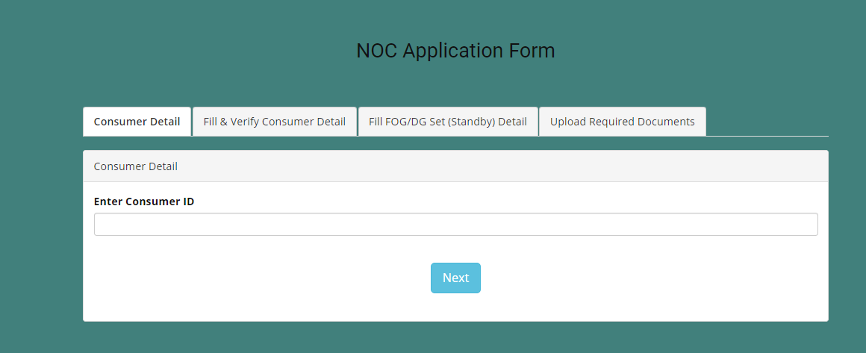

2nd Step: Enter applicant name and other details.
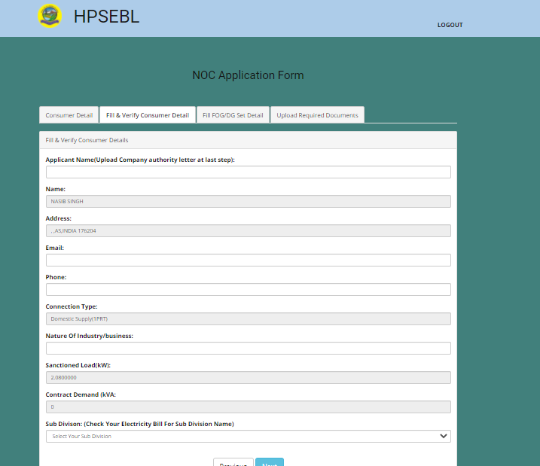

3rd Step: Enter FOG/DG Set (Standby) Details:
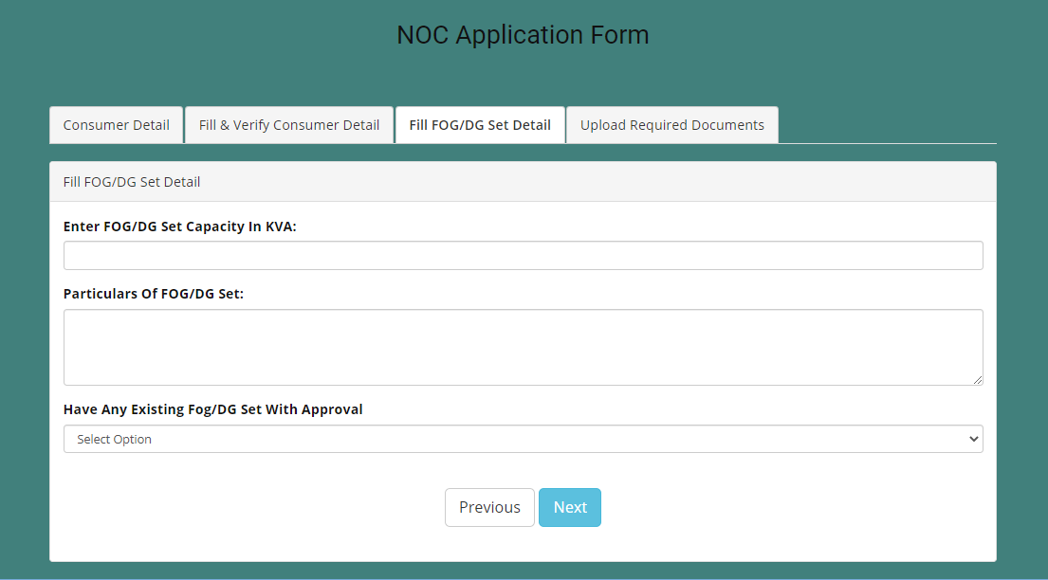

4th step: Upload all required documents (file formats accepted .pdf, .jpg, .jpeg, .png). While uploading applicant signature make you upload only image file in png,jpeg format (Image size must be 280X140).

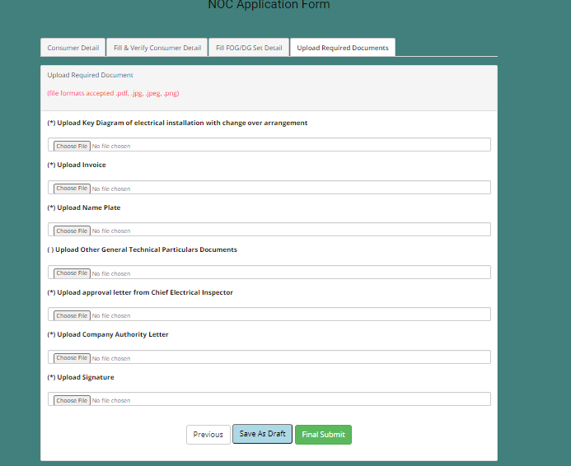

Final Submit or save draft for later submission. You will get a message from HPSEBL for successful application submission.

Pending Applications for Final Submit: In this screen you will all your saved draft applications. You can final submit applications from here after modifications or can delete application.

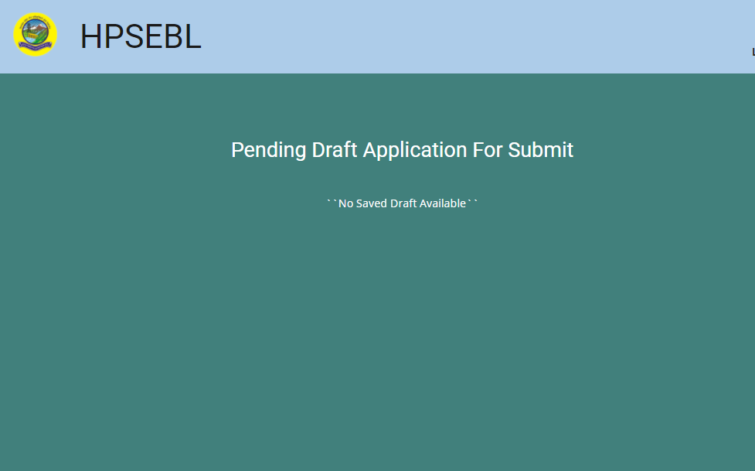

Check Application Status: In this screen you can check your application status. After approval you can download NOC from this screen. You can also download NOC application from this screen. You will get message from HPSEBL on application approval or rejection.
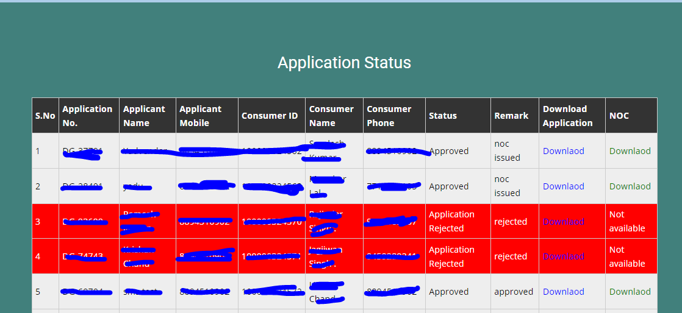

Raise Issue: You can raise your NOC related issue here.
